A Project Report on

**“Maps Scraper”**

Submitted by

**Shourish Kothawale-19202A0047**

**Shubham Jadhav-19202A0011**

**Shishir Nath-19202A0054**

**Piyush Nirbhavane-19202A0006**

Under the guidance of

**Sridevi Taradi**

Head of the Department

**Mrs. Yogita Jore**

**Department of Information Technology**

(NBA Accredited)



**Vidyalankar Polytechnic**

**Wadala (e), Mumbai – 400 037**

**Maharashtra State Board of Technical Education, Mumbai**

**2021 – 22 2020**

|  |
| --- |
| **Institute Vision** |

To achieve excellence in imparting **Technical Education** so as to meet the **Professional and Societal needs**.

|  |
| --- |
| **Institute Mission** |

* Developing **technical skills** by imparting knowledge and providing hands on experience.
* Creating an environment that nurtures **ethics, leadership and team building**.
* Providing **industrial exposure** for minimizing the gap between academics & industry.

|  |
| --- |
| **Program Vision** |

To become a leading center in the domain of Information Technology where learners are introduced to the concepts and implementation of technologies.

|  |
| --- |
| **Program Mission** |

M1:Encouraging academic excellence and a passion for learning through the use of learner-oriented teaching methodologies.

M2:Providing an environment that inculcates ethics and effective soft-skills and focuses on the development of learners.

M3:Establishing and reinforcing a symbiotic institute-industry interface so that learners can gain exposure to real-life applications of Information Technology.

|  |
| --- |
| **Program Education Objectives** |

PEO 1: Provide socially responsible, environment friendly solutions to Information technology related broad-based problems adapting professional ethics.

PEO 2: Adapt state-of-the-art Information Technology broad-based techniques to work in multi-disciplinary work environments.

PEO 3: Solve broad-based problems individually and as a team member communicating effectively in the world of work.

|  |
| --- |
| **Program Outcomes** |

**Basic and Discipline specific knowledge:** Apply knowledge of basic mathematics, science and engineering fundamentals and engineering specialization to solve the engineering problems.

**Problem analysis:** Identify and analyse well-defined engineering problems using codified standard methods.

**Design/ development of solutions:** Design solutions for well-defined technical problems and assist with the design of systems components or processes to meet specified needs.

**Engineering Tools, Experimentation and Testing:** Apply modern engineering tools and appropriate technique to conduct standard tests and measurements.

**Engineering practices for society, sustainability and environment:** Apply appropriate technology in context of society, sustainability, environment and ethical practices.

**Project Management:** Use engineering management principles individually, as a team member or a leader to manage projects and effectively communicate about well-defined engineering activities.

**Life-long learning:** Ability to analyse individual needs and engage in updating in the context of technological changes.

|  |
| --- |
| **Program Specific Outcomes** |

**Modern Information Technology:** Use latest technologies for operation and application of information.

**Information Technology Process:** Maintain the information processes using modern information and communication technologies.



**Certificate**

This is to certify that the following students

19202A0047– Shourish Kothawale

19202A0011 – Shubham Jadhav

19202A0054 – Shishir Nath

19202A0006 – Piyush Nirbhavane

Have completed the Project on

Maps Scraper

A partial fulfillment of the requirement of Third Year Diploma in Information Technology affiliated to Maharashtra State Board of Technical Education, Mumbai for the Academic Year 2021-22.

Internal Examiner External Examiner

Project Guide Head of Department Principal

**Acknowledgement**

We would like to thank all those who helped in all ways possible to complete this project. We would like to show special gratitude to our final year project guide, Mrs. Sridevi Taradi, whose contribution in stimulating suggestions and words of encouragement helped us to coordinate our project especially in writing reports, aiding us and correcting our mistakes along with being a strong support throughout this entire journey.

We are thankful to Mr. Ashish Ukidve, Principal of Vidyalankar Polytechnic, and Miss Yogita Jore, Head of Information Technology for all the support rendered to us during the entirety of this project and its processes. We also like to give a special thanks to Sahu Technologies to work on this project, which helped us test an improve our skills to the fullest.

Furthermore, we would like to acknowledge with much appreciation the crucial role of all those who gave permission to use all required equipment and necessary material to complete the task. A very special thanks to us as a team who invested their valuable time and efforts into this project. With only unity and coordination were we able to complete this project, and were always understanding and helpful to each other since the commencement. Without the support and the unity of each one of us we would have not been able to achieve of our task today.

**Abstract**

Information is paramount nowadays and is seemingly growing day by day. If correct information is delivered quickly, it can be a highly effective in situations. New technology is being discovered daily to deliver data as quickly and efficiently as possible. To provide a solution to this problem we will create a data/web scraper for Google Maps for providing different kinds of data like name, phone, website etc. Web Scrapers allow to find specific data on the internet and then export them into spreadsheets like Microsoft Excel sheet or a CSV file. Web Scrapers are created to extract personalised data hence this project will focus on extracting data through the Google Maps website. Most of the times these scrapers are used to extract data from HTML documents, but sometimes they can even extract data through CSS and JavaScript. Web Scrapers are of many types from self-built to pre-built, and can be available in Software, and Browser extension formats. These web scrapers are built in many different programming languages, but python seems to be the most popular of them all as it has many different libraries that are perfect for the job. Scrapers not only have many functions, but they also have many applications. They can be used in business analytics as it can help analyse competition. Market Research is one of the major uses of the scrapers as the data is specific and can be used to identify various trends in the market.

**Table of Contents**

|  |  |  |
| --- | --- | --- |
| **Sr. No** | **Title** | **Pg. No** |
| 1 | Chapter 1: Introduction | **1** |
| 2 | Chapter 2: Review of Literature | **4** |
| 3 | Chapter 3: Plan of Work | **8** |
| 4 | Chapter 4: System Requirement | **10** |
| 5 | Chapter 5: Designing | **12** |
| 6 | Chapter 6: Module Description | **20** |
| 7 | Chapter 7: Testing | **22** |
| 8 | Chapter 8: Advantages and Drawbacks | **30** |
| 9 | Chapter 9: Application | **32** |
| 10 | Chapter 10: Screenshots | **34** |
| 11 | Chapter 11: Conclusion | **40** |
| 12 | Chapter 12: Bibliography | **42** |

**List of Tables and Figures**

|  |  |  |
| --- | --- | --- |
| **Sr. No** | **Title** | **Pg. No** |
| 1 | Table 1: Market Survey | **7** |
| 2 | Figure 1: Plan of Work | **9** |
| 3 | Figure 2: Use Case Diagram | **13** |
| 4 | Figure 3: Sequence Diagram | **14** |
| 5 | Figure 4: DFD Level 0 | **15** |
| 6 | Figure 5: DFD Level 1 | **16** |
| 7 | Figure 6: DFD Level 2 | **17** |
| 8 | Figure 7: Flowchart | **18** |
| 9 | Figure 8: ER Diagram | **19** |
| 10 | Table 2: Test Cases | **23** |

**CHAPTER 1**

**INTRODUCTION**

# 1. INTRODUCTION

Data Scraping is also known as web scraping. It is the process to import information from a website to a spreadsheet or local file. It can help get data easily, and also help to channel data to other websites. Data Scraping can be used in many places in the modern day, from price monitoring, market research to even Sentiment Analysis. Web Scraping has many applications and has a wide variety of usage. Google Maps is a website full of information. It contains the location of a place and even pinpoints it, and it has many different attributes for places like contact numbers, websites, contact number, rating, review count, timings etc. It is a place which contains a lot of data, and efficient scraping of the website can be done helping many causes.

The main aim of the application is to extract the data as quickly and efficiently as possible. Since getting information is important for many reasons this app will be very helpful in doing so. The app will help with this as it with be able to pick out the appropriate data from a page with unstructured data and then will do it way quicker than someone sitting and manually noting down the data in an excel sheet which might take hours.

The application will have an array of functionalities, which starts off with searching for the place using an URL. This URL has to be specific to that of the place they want to search so they can do this by providing the google maps URL for their preferred place. The next feature that will be available in the application is the use of keywords. The user can simply enter a keyword like “Pizza places Mumbai” and get the attributes such as the address (location), review count, rating, timings, contact number, and website of the places that show in the result of the place. This can help gather data quickly from the google maps page as it will be able to scan all the relevant data on the place. Another way to search will be simply through providing the location name, like “Mumbai”, “Paris” to search for places related to it. The next functionality that will be in the application is the filter option. Users will have an option to either keep the data with a blank phone number field or to remove the data. This helps get more personalised results. After searching all the data this data has to be saved. To do this we will eb allowing the user to import the data into two formats. The first format which will be used is Microsoft Excel spreadsheet which has a .xlsx extension. The second import format will be CSV with a .csv extension. The only prerequisite for the user will be that they have to prepare the excel sheet with its name beforehand. There will be buttons to execute the import.

With data increasing daily it is becoming more and more difficult to extract the appropriate data online. Since information is so important nowadays this project will surely play its part to accomplish its main goal. Sites with abundant unstructured data can be easily broken down extracting the appropriate data within a matter of seconds. With Google maps being online for so many years accumulating a lot of data, it will be a website that will help in extracting data online. This data can then be used for many purposes, and the use of the application is limitless.

**Problem Statement:**

In today’s world information plays a very important part. Practically, everything we do requires information. With the world advancing information is growing and expanding at an extraordinary pace. With this comes the problem of unstructured data everywhere, along with redundant data. Every second new data is being created, for example with Google over 40,000 search queries are made every second, that’s a whopping 1.2 trillion searches per year. Around 44 zettabytes With so much data it is becoming more and more difficult to find data that is appropriate to the cause and in turn is making it difficult to find it. This can cause a major crisis for many people as the world works on data, from businesses to science data is integral. To perform appropriate searches data scrapers can be used. Data scrapers help to find only the appropriate data in a website so that you don’t have to search for the data on your own manually.

After looking through various data scraper one common thing was, they were subscription based, and they only had one option to search by that was using keywords. But with our Google Maps Web Scraper we will be provided to search for places using location, URL, Keyword and even a special search option for restaurants since they have different attributes compared to other types of location with generic characteristics.

Google maps contains a lot of data about a place from location to opening times, popular hours etc. These types of data can be used by businesses to analyze and formulate the correct strategy. Not only businesses but many other people who like to travel can search for data on famous places to plan out their next trip. Data Scrappers are not limited to a specific group of people, they can be used by everyone to find information about their liking.

**CHAPTER 2**

**REVIEW OF LITERATURE**

# 2. REVIEW OF LITERATURE

For Market research we looked through the internet for different data scrapers and also looked for specific Google Maps data scrapers. We looked at the features of each app and noted them down along with their obvious disadvantages. We looked through web scrapers both paid and unpaid. We downloaded all the apps and tested each of them.  
  
**Apps we looked through:**

* Web Scraper- Free Web Scraping
* DigLead: Business Lead Scraper
* Google Map Business Scrapper
* Google Map Scrapper Listing
* Leads Extractor - Google Maps Scraper

|  |  |  |  |
| --- | --- | --- | --- |
| Logo | App Name | Features | Disadvantages |
|  | Web Scraper - Free Web Scraping | * Data scraping from multiple pages;  * Multiple data extraction types (text, images, URLs, and more);  * Scraping data from dynamic pages (JavaScript + AJAX, infinite scroll);  * Browsing scraped data;  * Exporting scraped data from a website to Excel | The GUI for this web extension is not user friendly, and it is difficult to use for the layman. |
|  | DigLead: Business Lead Scraper | Main Features:  -Targeted List Generator  -Webpage or Website Email Scraper  -Google My Business Listings Scraper (Google Maps/GMB Scraper)  -Yelp Lead Extractor  -Export/Download all scraped leads in Excel Spreadsheet which can be share via email or open with spreadsheet viewer. | Even if installing the app is free it contains a subscription fee to use it. Also, it has limited functionality. |
|  | Google Map Business Scrapper | instantly generate a ton of leads, anywhere in the world. This Google maps extractor tool extracts **name, address, phone number, website, social media links, reviews, current marketing pixels** and more from companies. | This app is paid so not everyone will afford it. |
| *No Image* | Google Map Scrapper Listing | Software Extract All Detail from Google Business  Name  Phone  Email – if email available on website for particular Business Website  Website  Rating  Review  Images – with Live Link and Also Download images into Local Computer  Business Closing Hours  Software Download Business images into Local Computer with Business Name Folder separately  Software Search Google Business Contact Location Wise Filter.  100% Real Time Extract Business Contact with Advance Export into Excel, CSV and Text Format. | This app is paid at a high price of $22 |
|  | Leads Extractor - Google Maps Scraper | * Find leads for your business in any industry across all countries  * Qualify leads faster than ever before  * Increase productivity by reducing hours spent looking for leads | Limited number of options as they are only limited to a combo box. |

Table 1: Market Survey

The observations from this research were that the results from the applications generated many blank fields. The reason for this was the data that was requested was never present in the structure of the data. Hence, we decided to add unique personalized tabs for each type of points of interests, like location, restaurants, which contain different attributes in its structure.

**CHAPTER 3**

**PLAN OF WORK**

# 3. PLAN OF WORK

May

Figure 1: Plan of Work

**CHAPTER 4**

**SYSTEM REQUIREMENTS**

## 4.1 HARDWARE REQUIREMENTS

System: Windows 11

Hard Disk: 1TB

RAM: 8GB

## 4.2 SOFTWARE REQUIREMENTS

Operating system: Windows

Database: SQLite

Programming Language: Python, JavaScript ES6

IDE Used for Coding: PyCharm IDE

**CHAPTER 5**

**DESIGNING**

## 5.1 USECASE DIAGRAM

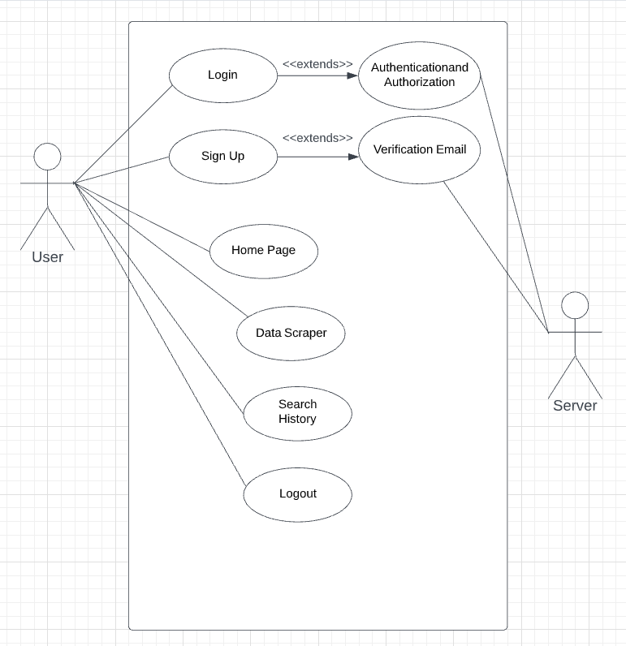

Figure 2: Use Case Diagram

## 5.2 SEQUENCE DIAGRAM

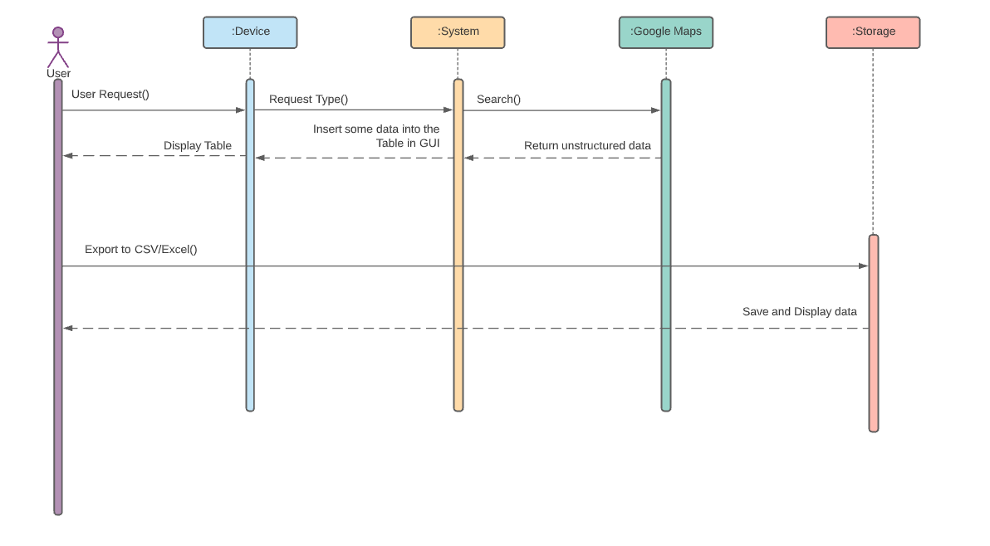

Figure 3: Sequence Diagram

## 5.3 DATA FLOW DIAGRAM (LEVEL 0,1,2)

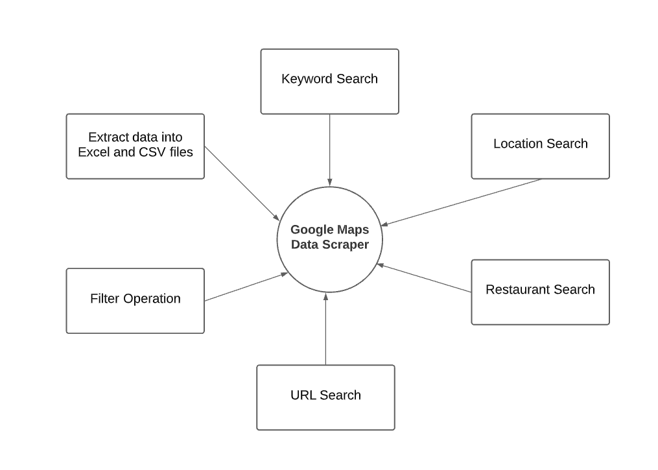

Figure 4: DFD Level 0

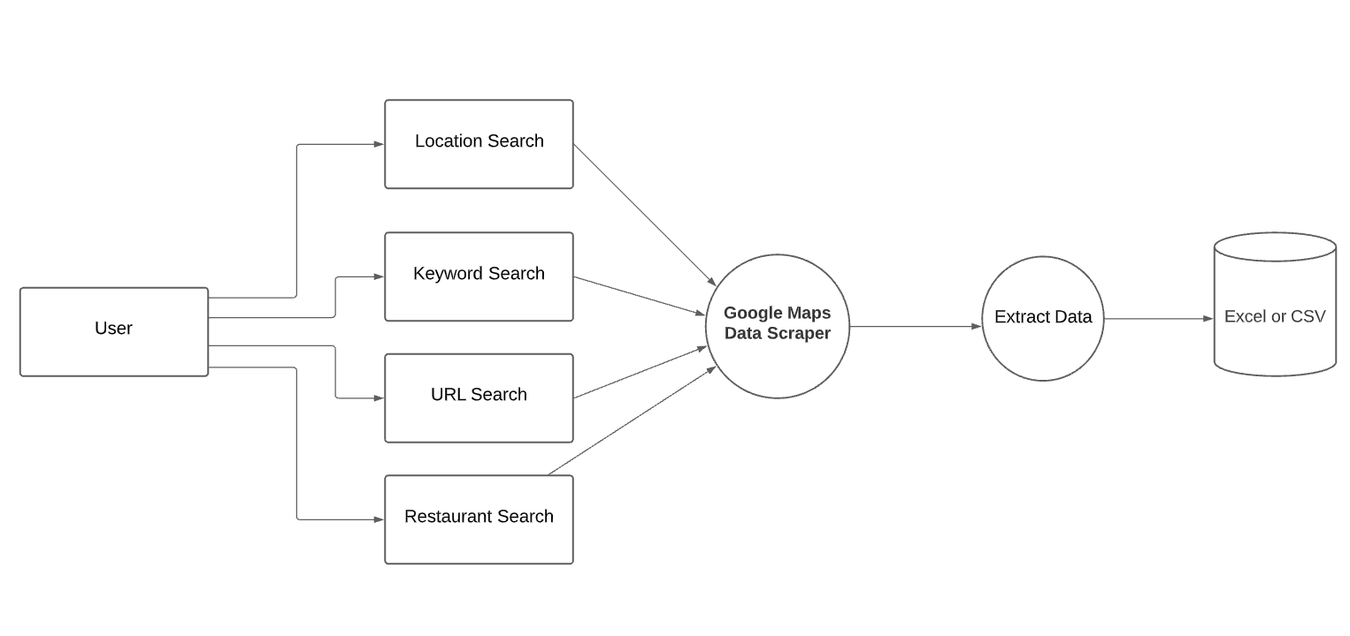

Figure 5: DFD Level 1

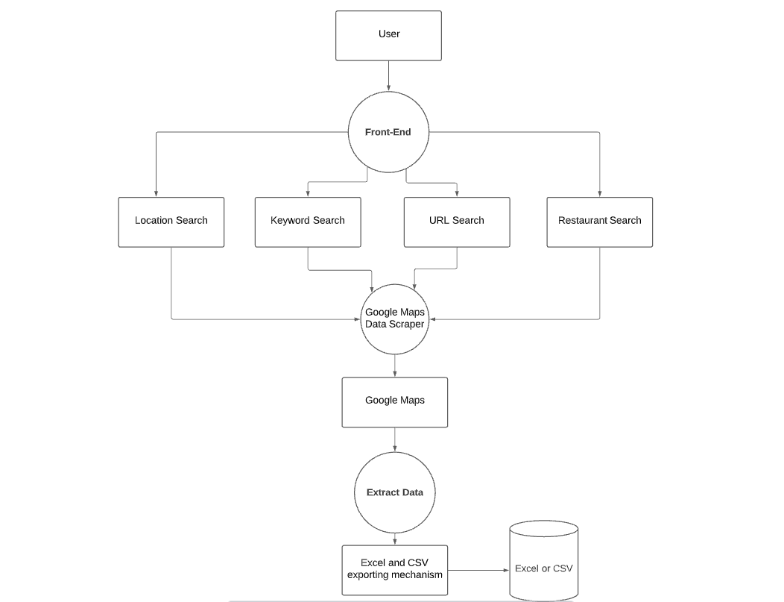

Figure 6: DFD Level 2

## 5.4 FLOWCHART

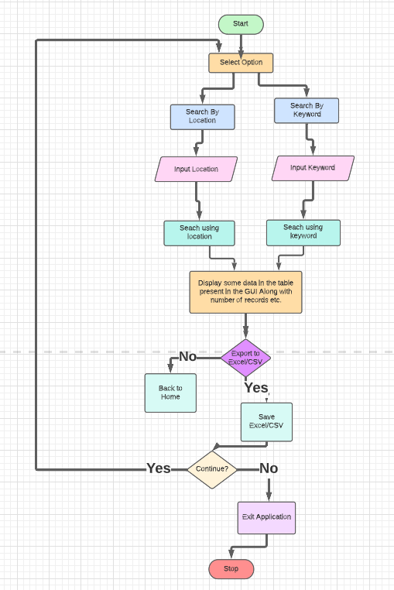

Figure 8: Flowchart

Figure 7: Flowchart

**5.5 ER DIAGRAM**

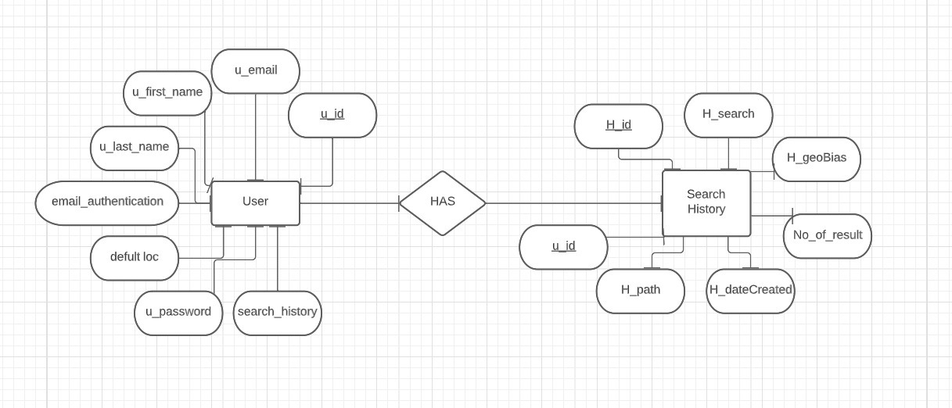

Figure 8: ER Diagram

**CHAPTER 6**

**MODULE DESCRIPTION**

# 6. MODULE DESCRIPTION

* **LOGIN**
* **LOGOUT**
* **HOME PAGE**
* **DATA SCRAPER**
* **SEARCH HISTORY**
* **SIGN UP**

**SIGN UP:**

The Signup module allows users to sign up (or register, as in register for a class)

We have used a registration confirmation mechanism that forces the user to respond to a “Confirm Registration” email sent after successful registration to verify his email address and activate his account. The user does this by clicking a unique activation link sent to them over email.

**LOGIN:**

The Login Module is a portal module that allows users to type a username and password to log in

**LOGOUT:**

Logging out means to end access to a website. Logging out will inform our website that the current user wishes to end the login session.

**HOME PAGE:**

A home page is the main web page of a website.

Our home page provides search history and our map data scrapper.

**DATA SCRAPER:**

A seamless tools which provides easy map scrapping solutions. Provides data in excel and csv format.

**SEARCH HISTORY:**

Logs all the data searched and stored the data files. Easy download with a single click.

**CHAPTER 7 TESTING**

# 7. TESTING

Software testing is a process, to evaluate the functionality of a software application with an intent to find whether the developed software met the specified requirements or not and to identify the defects to ensure that the product is defect free in order to produce the quality product.

## 7.1 TEST CASES

## Login Test Case

|  |  |  |  |  |  |
| --- | --- | --- | --- | --- | --- |
| **SR.NO** | **ACTION** | **INPUT** | **EXPECTED**  **OUTPUT** | **ACTUAL**  **OUTPUT** | **STATUS** |
| 1 | Login (valid) | 1.Enter E-mail ="abc123@domain.com”  2.Enter Password="*******"  3.click on login button | It should accept the Username and  Password | It accepts the  Username | Pass |
| 2 | Login  (Invalid) | 1.Enter E-mail ="abc123@domain.com”  2.Enter Password="*******"  3.click on login button | It should prompt  wrong  username  Password | It is  prompting wrong username Password | Pass |
| 3 | Login  (Invalid User not registered) | 1.Enter E-mail ="abc123@domain.com”  2.Enter Password="*******"  3.click on login button | It should prompt  User not registered and redirect to sign-up page. | It is  prompting user not registered, and redirecting to sign-up page. | Pass |
| 4 | Login  (Invalid) | 1. Enter Email=" "  2.Enter Password=" "  3.click on login button | It should prompt  please fillout  this field | It is  prompting please fillout this field | Pass |
| 5 | Login (Invalid Email) | 1. Enter Email="xyz"  2.Enter Password="*******"  3.click on login button | It should prompt email doesn’t exist. | It prompts email doesn’t exist. | Pass |

## Sign Up Test Case

|  |  |  |  |  |  |
| --- | --- | --- | --- | --- | --- |
| **SR.NO** | **ACTION** | **INPUT** | **EXPECTED**  **OUTPUT** | **ACTUAL**  **OUTPUT** | **STATUS** |
| 1 | Sign-up (valid) | 1. Enter E-mail ="abc123@domain.com”  2.Enter First Name="abc"  3. Enter Last Name=”xyz”  4. Password= “******”  5. Confirm Password= “******”  6. Default Location= “Mumbai” | It should accept the Details and send a verification mail. | It accepts the Details and sends a verification mail. | Pass |
| 2 | Sign-up (Invalid) | 1. Enter E-mail ="abc123@domain.com”  2.Enter First Name="abc"  3. Enter Last Name=”xyz”  4. Password= “***”  5. Confirm Password= “******”  6. Default Location= “Mumbai” | It should prompt passwords dson’t match. | It prompts passwords don’t match. | Pass |
| 3 | Sign-up (Invalid) | 1. Enter E-mail =" ”  2.Enter First Name=" "  3. Enter Last Name=” ”  4. Password= “ ”  5. Confirm Password= “ ”  6. Default Location= “ ” | It should prompt please don’t leave any fields blank. | It prompts please don’t leave fields blank. | Pass |
| 4 | Sign-up (Sending Verification Mail) | 1. Enter E-mail ="abc123@domain.com”  2.Enter First Name="abc"  3. Enter Last Name=”xyz”  4. Password= “***”  5. Confirm Password= “******”  6. Default Location= “Mumbai” | It should send a verification mail. | It sends a verification mail. | Pass |
| 5 | Sign-up (Verification Mail completes sign-up) | 1. Enter E-mail ="abc123@domain.com”  2.Enter First Name="abc"  3. Enter Last Name=”xyz”  4. Password= “***”  5. Confirm Password= “******”  6. Default Location= “Mumbai” | It should prompt user registered successfully after clicking the link in the mail redirecting to the login page. | It prompts user rgistered successfully after clicking the link in the mail redirecting to the login page. | Pass |
| 6 | Sign-up  (Invalid) | 1. Enter E-mail ="ab”  2.Enter First Name="a"  3. Enter Last Name=”x”  4. Password= “***”  5. Confirm Password= “*”  6. Default Location= “Mu” | It should prompt input invalid and say the minimum number for the invalid entity. | It prompts input invalid and says the minimum number for the invalid entity. | Pass |

## HOME PAGE Test Case

|  |  |  |  |  |  |
| --- | --- | --- | --- | --- | --- |
| **SR.NO** | **ACTION** | **INPUT** | **EXPECTED**  **OUTPUT** | **ACTUAL**  **OUTPUT** | **STATUS** |
| 1 | Home Page | Visit Page | All links and animations should work. | All links and animations work. | Pass |

## Data Scraper Test Case

|  |  |  |  |  |  |
| --- | --- | --- | --- | --- | --- |
| **SR.NO** | **ACTION** | **INPUT** | **EXPECTED**  **OUTPUT** | **ACTUAL**  **OUTPUT** | **STATUS** |
| 1 | Data Scraper (valid) | 1. Enter Query ="pizza”  2.Enter Location="Mumbai,India"  3. Enter Radius=”10”  4. Limit= “100”  5. File name= “pizza-mumbai”  6. File type= “Excel/CSV” | Data scraped successfully should be prompted along with redirection to the search history page | Page redirected along with prompt | Pass |
| 2 | Data Scraper (Blank Location) | 1. Enter Query ="pizza”  2.Enter Location=" "  3. Enter Radius=”10”  4. Limit= “100”  5. File name= “pizza-mumbai”  6. File type= “Excel/CSV” | Should use the current users default location for nearby search. | Succefully scrapes data using default location. | Pass |
| 3 | Data Scraper (Blank Radius) | 1. Enter Query ="pizza”  2.Enter Location="Mumbai"  3. Enter Radius=””  4. Limit= “100”  5. File name= “pizza-mumbai”  6. File type= “Excel/CSV” | It should take default radius as 10 and scrape data. | Successfully scraped data. | Pass |
| 4 | Data Scraper (Blank Limit) | 1. Enter Query ="pizza”  2.Enter Location="Mumbai"  3. Enter Radius=”10”  4. Limit= “”  5. File name= “pizza-mumbai”  6. File type= “Excel/CSV” | It should take default limit as 100 and scrape data. | Successfully scraped data. | Pass |
| 5 | Data Scraper (Blank Inputs) | 1. Enter Query ="”  2.Enter Location=""  3. Enter Radius=””  4. Limit= “”  5. File name= “”  6. File type= “” | Should prompt blank record error for appropriate entity. | Prompts the errors. | Pass |
| 6 | Data Scraper (No Results) | 1. Enter Query ="sahfgfsgfsd”  2.Enter Location="ijiotjreo"  3. Enter Radius=”10”  4. Limit= “100”  5. File name= “pizza-mumbai”  6. File type= “Excel/CSV” | Should prompt no results found error message. | Prompts the error. | Pass |
| 7 | Data Scraper (Invalid Data types for inputs) | 1. Enter Query ="pizza”  2.Enter Location="Mumbai"  3. Enter Radius=”abc”  4. Limit= “xyz”  5. File name= “pizza-mumbai”  6. File type= “Excel/CSV” | Should prompt datatype error for appropriate input. | Prompts the error. | Pass |
| 8 | Data Scraper (Invalid file format selection) | 1. Enter Query ="pizza”  2.Enter Location="Mumbai"  3. Enter Radius=”abc”  4. Limit= “xyz”  5. File name= “pizza-mumbai”  6. File type= “Please choose a file format” | Should prompt an error instructing to select a file format. | Prompts error. | Pass |
| 9 | Data Scraper (Invalid file name) | 1. Enter Query ="pizza”  2.Enter Location="Mumbai"  3. Enter Radius=”abc”  4. Limit= “xyz”  5. File name= “pizza-mumbai”  6. File type= “Please choose a file format” | Should prompt that the file name already exists please choose another name. | Prompts the file name exists. | Pass |
| 10 | Data Scraper (File scraping in the appropriate format) | 1. Enter Query ="pizza”  2.Enter Location="Mumbai"  3. Enter Radius=””  4. Limit= “100”  5. File name= “pizza-mumbai”  6. File type= “Excel/CSV” | Should scrape data for either format | The Data is scraped successfully. | Pass |

## Search History Test Case

|  |  |  |  |  |  |
| --- | --- | --- | --- | --- | --- |
| **SR.NO** | **ACTION** | **INPUT** | **EXPECTED**  **OUTPUT** | **ACTUAL**  **OUTPUT** | **STATUS** |
| 1 | Search History (download) | Click download | Should download data into the download folder of the device. | Downloads data into the download folder. | Pass |
| 2 | Search History (display of data) | View Page | All old and new data scraped along with it’s meta data must be present in table format. | Data is present correctly and in a table. | Pass |

## Logout Test Case

|  |  |  |  |  |  |
| --- | --- | --- | --- | --- | --- |
| **SR.NO** | **ACTION** | **INPUT** | **EXPECTED**  **OUTPUT** | **ACTUAL**  **OUTPUT** | **STATUS** |
| 1 | Logout | Click the logout button | Should logout the user. | User logged out | Pass |
| 2 | Logout | Click the logout button | The user musn’t be able to use other services after logout | User logged out | Pass |

Table 2: Test Cases

**CHAPTER 8**

**ADVANTAGES AND DRAWBACKS**

# 8. ADVANTAGES AND DRAWBACKS

## 8.1 ADVANTAGES

* Sorting out data. The data displayed on the screen on Google Maps is an elaborate mix match of people, addresses, sites and names. ...
* Scraping professional listings. ...
* Speed and accuracy. ...
* Collection of valuable geographical info. ...
* Operational benefits. ...
* Wide range of data can be collected.
* Inexpensive
* Easy to implement
* Low maintenance and speed
* Accuracy

## 8.2 DISADVANTAGES

* Difficult to analyze – For anybody who is not an expert, the scraping processes are confusing to understand. Although this is not a major problem, but some errors could be fixed faster if it was easier to understand for more software developers.
* Data analysis – The data that has been extracted will first need to be treated so that they can be easily understood. In certain cases, this might take a long time and a lot of energy to complete.
* Time – It is common for new data extraction applications to take some time in the beginning as the software often has a learning curve. Sometimes web scraping services take time to become familiar with the core application and need to adjust to the scrapping language. This means that such services can take some days before they are up and running at full speed.
* Speed and protection policies – Most web scrapping services are slower than API calls and another problem is the websites that do not allow screen scrapping. In such cases web scrapping services are rendered useless. Also, if the developer of the website decides to introduce some changes in the code, the scrapping service might stop working.

**CHAPTER 9**

**APPLICATIONS**

# 9. APPLICATIONS

* **Lead Generation**

One incredibly popular use of web scraping is lead generation. In short, web scraping is used by many companies to collect contact information about potential customers or clients. This is incredibly common in the business-to-business space, where potential customers will post their business information publicly online.

* **Real Estate Listing Scraping**

Many real estate agents use web scraping to populate their database of available properties for sale or for rent.

* **Data Analysis**

You might want to collect and analyse data related to a specific category from multiple websites. The category might be real estate, automobiles, electronic gadgets, industrial equipment, business contacts, marketing etc.

* **Academic Research**

Data is an integral part of any research, be it academic, marketing or scientific. A Web Scraper will help you gather structured data from multiple sources in the Internet with ease.

* **Training and Testing Data for Machine Learning Projects**

Web Scraping helps you to gather data for testing / training your Machine Learning models. Quality of your machine learning models depends on the quality of training data used and when the data is not readily available you can employ web scraping to collect it from various websites.

**CHAPTER 10**

**SCREENSHOTS**

# 10. SCREENSHOTS

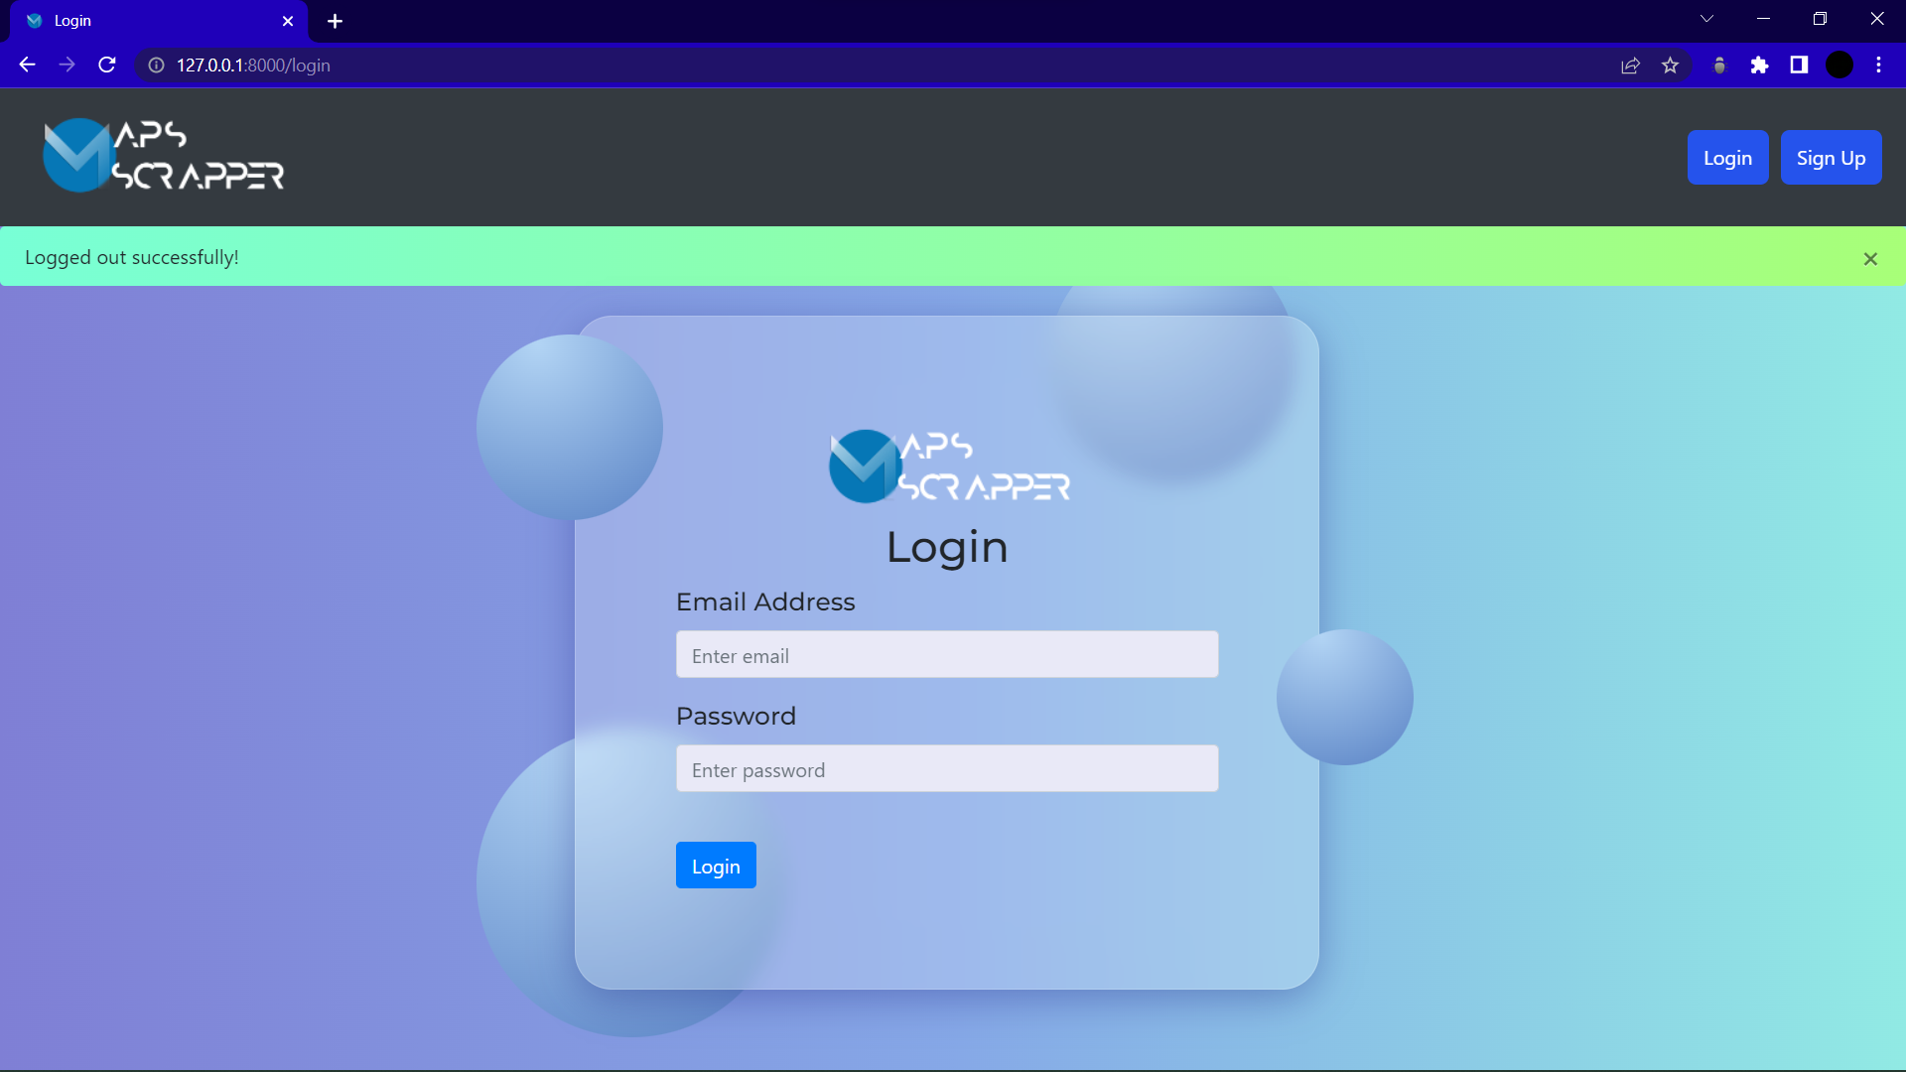

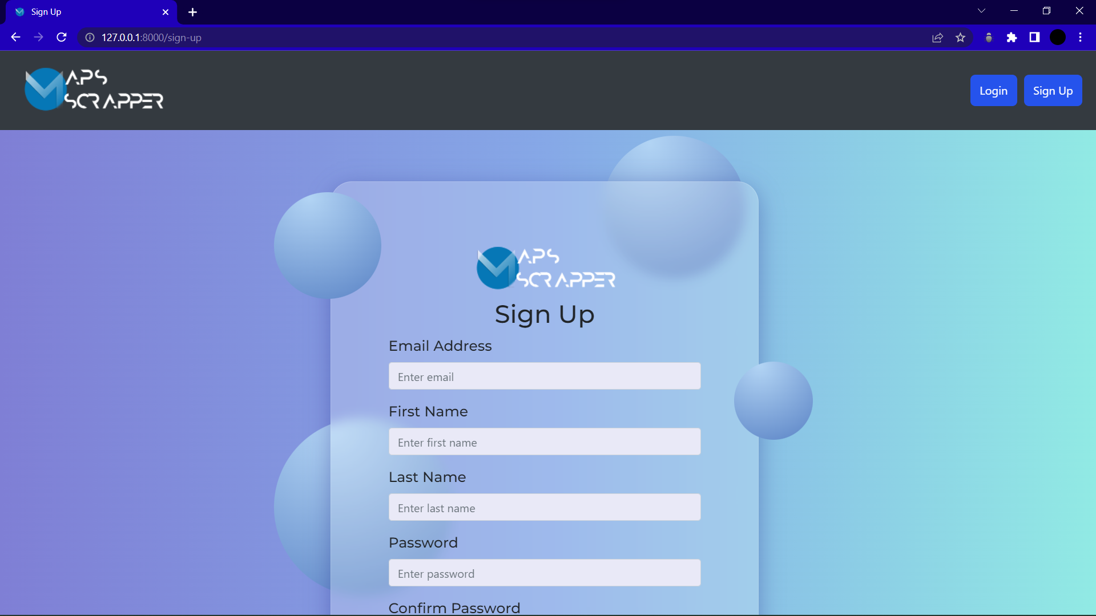

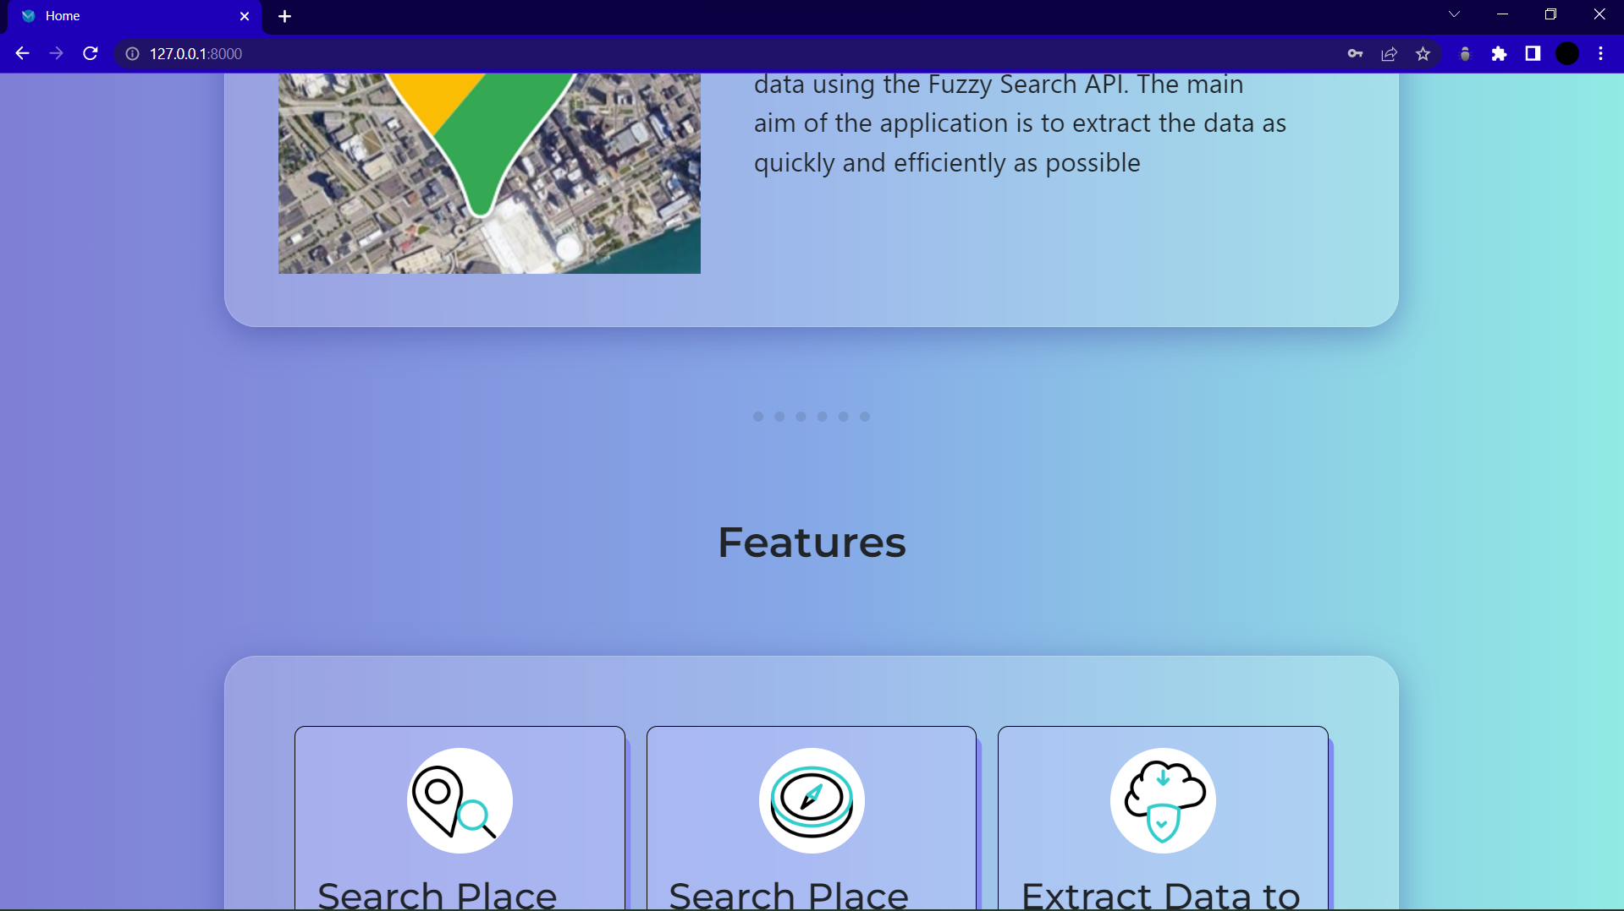

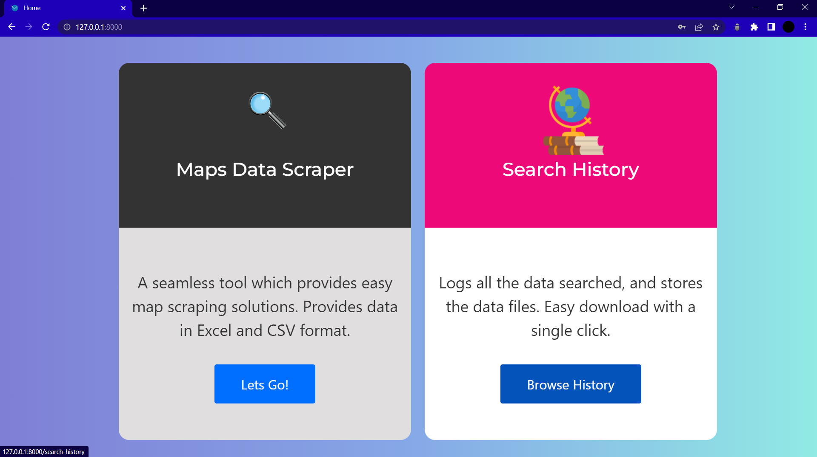

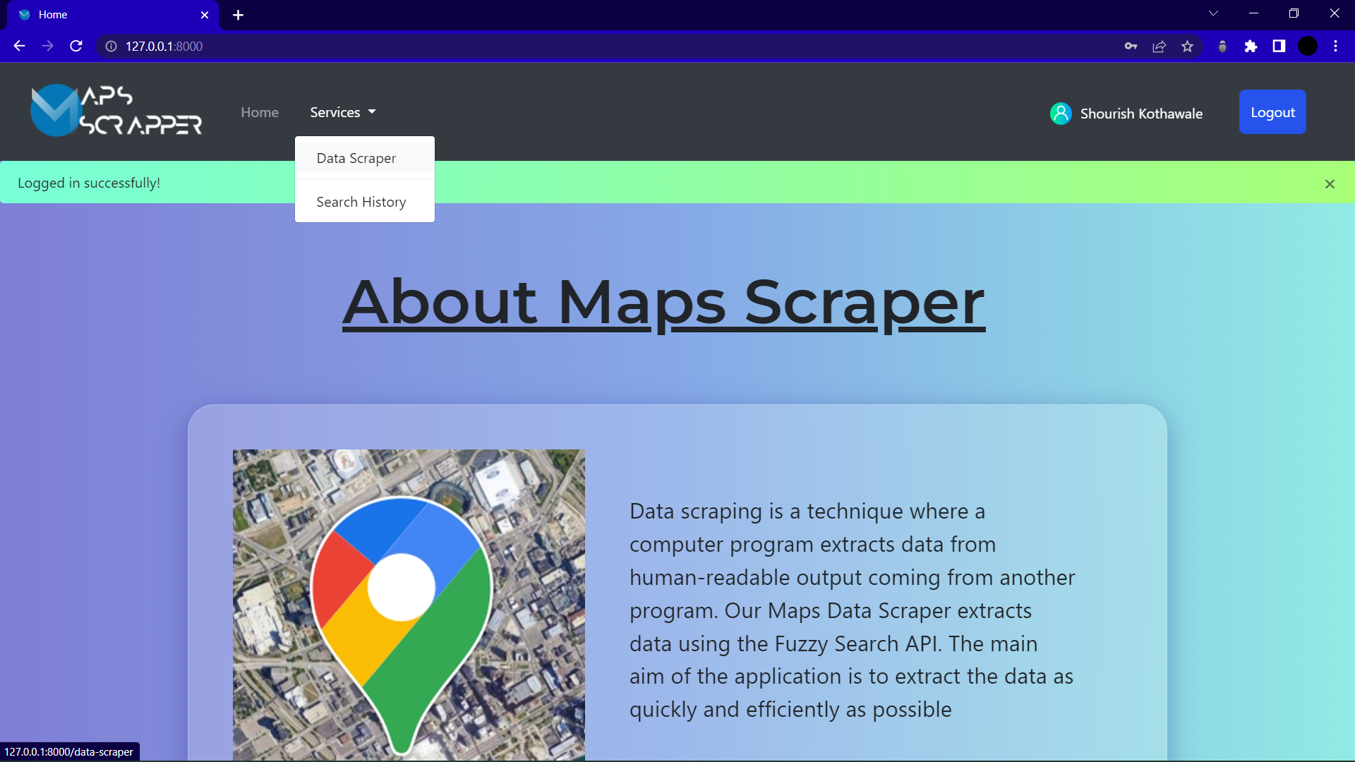

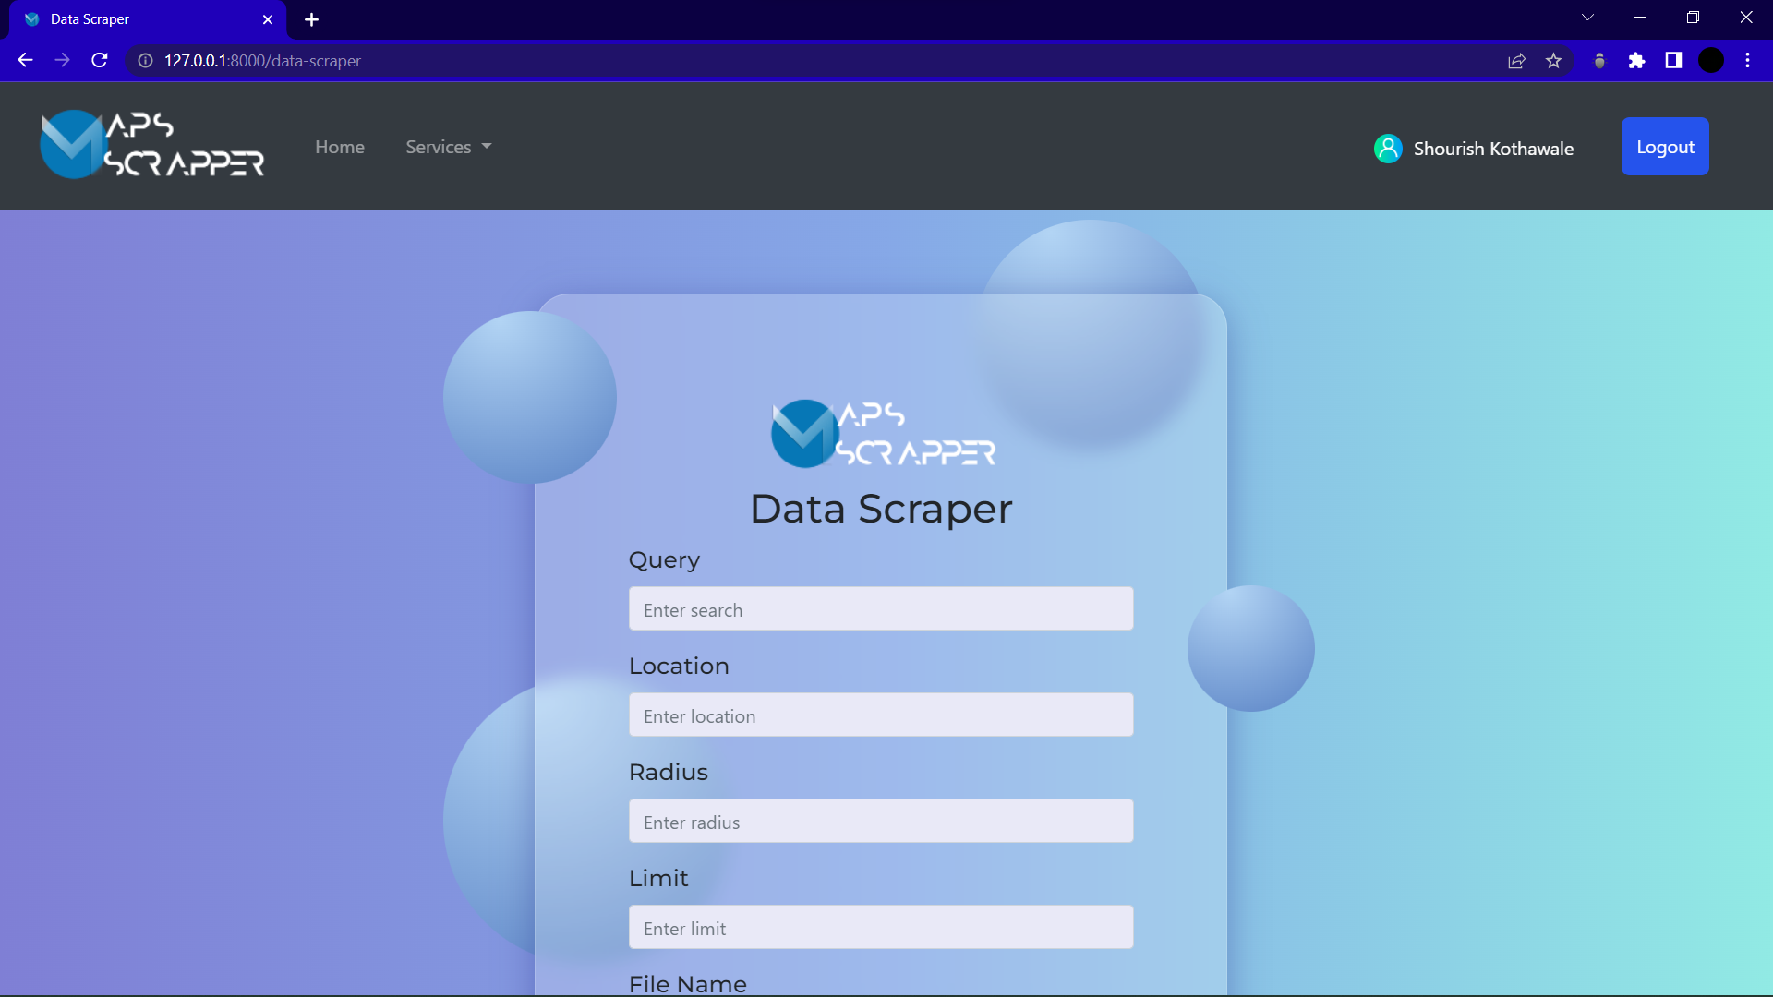

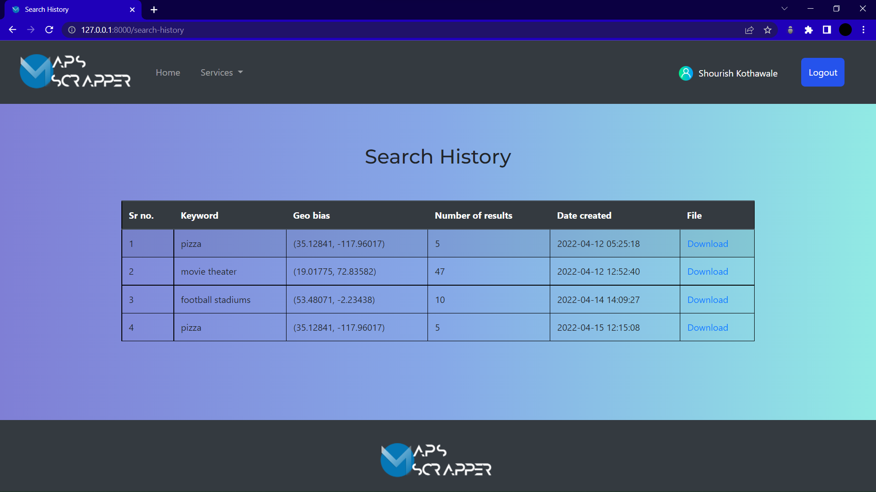

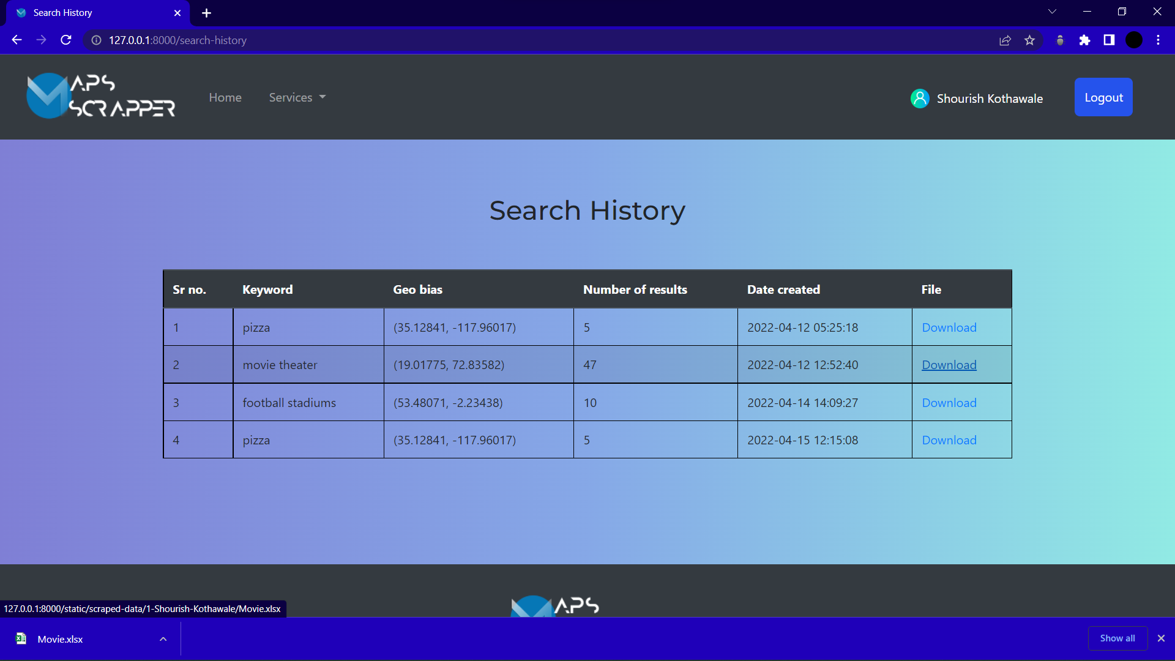

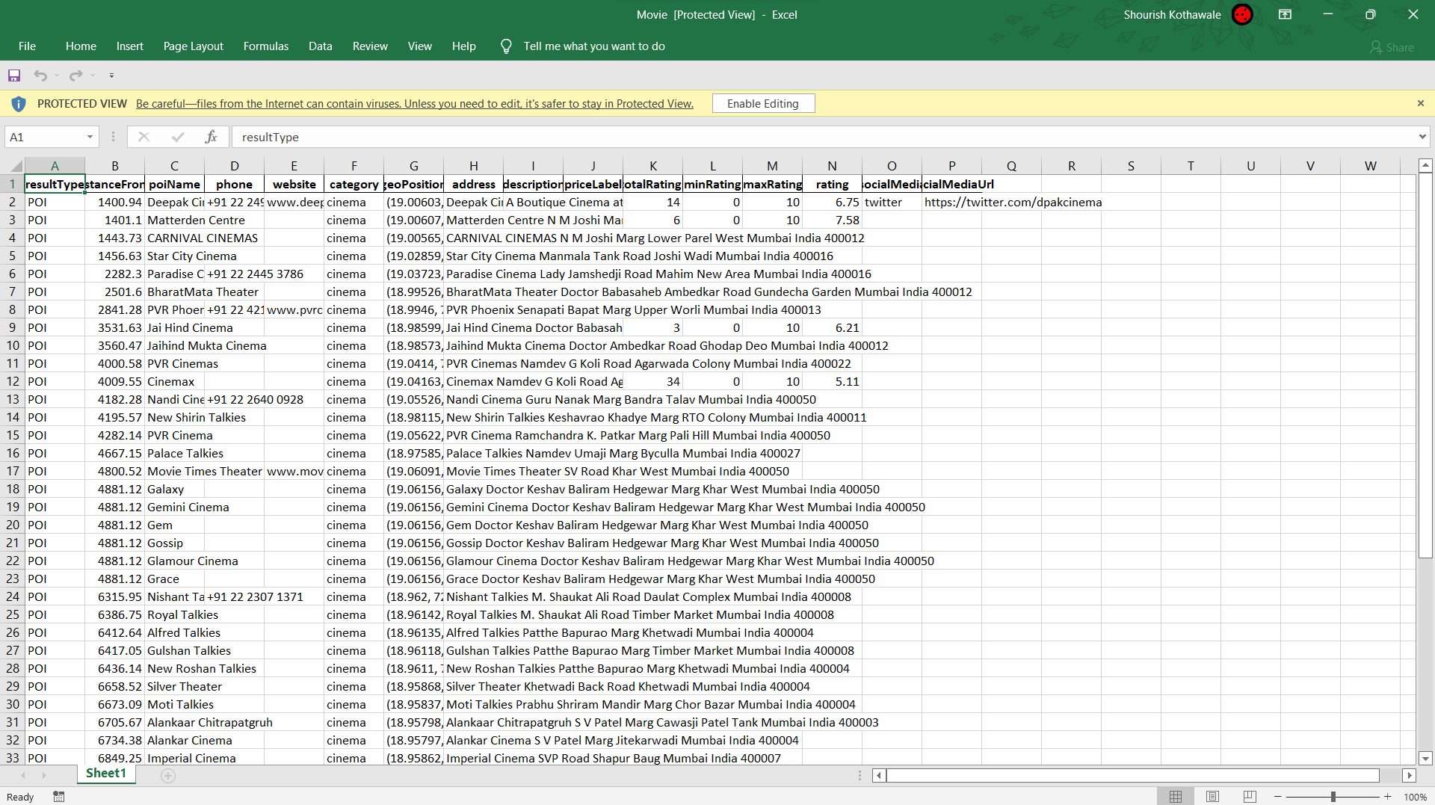

**CHAPTER 11**

**CONCLUSION**

# 11. CONCLUSION

To conclude, the Google Maps data scraper will offer a variety of personalised search features, at a free cost. Since information is vital nowadays it will help in the cause. It will contain various search parameters from, keywords, location, to even URLs. Due to restaurants having different structures we will be providing a unique feature only known to our app that provides special searches for restaurants. The users will later also be able to export the data in to Excel or CSV formats in their prepared sheets. Use of Python and it’s libraries will be vital for the completion of the project.

The main aim of this project is to make it easier and quicker to find data. Hence this we scraper helps as it can save time and even makes it easier to view data. This data scraper can not only be useful in business fields but can be used for various other analytical and statistical reasons.

**CHAPTER 12**

**BIBLIOGRAPHY**

# 12. References

1. [https://chrome.google.com/webstore/detail/web-scraper-free-web- scra/jnhgnonknehpejjnehehllkliplmbmhn?hl=en](https://chrome.google.com/webstore/detail/web-scraper-free-web-scra/jnhgnonknehpejjnehehllkliplmbmhn?hl=en) - Web Scraper-Free Web scraping extension
2. <https://play.google.com/store/apps/details?id=com.lead.dig&hl=en_IN&gl=US> - DigLead Business Lead Scrapper
3. <https://chrome.google.com/webstore/detail/google-map-business-scrap/lfeafcjdmideekklmmioaaaonahmhioe?hl=en> – Google Map Business Scrapper Extension
4. <https://chrome.google.com/webstore/detail/leads-extractor-google-ma/gaojpolkokdnlbdnejallmpmcigpnhan?hl=en> – Leads Extractor
5. <https://www.targetinternet.com/what-is-data-scraping-and-how-can-you-use-it/> - what is data scrapping and how to use it
6. <https://www.edureka.co/blog/web-scraping-with-python/> - Web Scrapping Libraries and brief introduction
7. <https://medium.com/swlh/scraping-google-maps-using-selenium-3cec08eb6a92> - How to scrape from google Chrome
8. <https://www.crummy.com/software/BeautifulSoup/bs4/doc/> - Beautiful Soup Documentation
9. <https://www.selenium.dev/documentation/> - Selenium Documentation
10. <https://chromedriver.chromium.org/downloads> - Chrome Driver
11. <https://developers.google.com/maps> - Google maps API Docs
12. <https://www.youtube.com/watch?v=HChq5_7yTGk&list=PL3JVwFmb_BnQrh3CFjyxD4vfyZ7ovvDLK> – Google Maps API and Python
13. <https://pypi.org/project/googlemaps/> - PyPi googlemaps python client
14. <https://www.geeksforgeeks.org/what-is-web-scraping-and-how-to-use-it/> - what is web scraping
15. <https://www.zyte.com/blog/web-scraping-requirement-gathering/> - Web scraping steps
16. <https://www.lucidchart.com/pages/> - Lucidchart

**INDUSTRY CERTIFICATES**

